Microsoft Azure - Starter Kits for Partners

Hands son Lab

Intelligent Apps Scenario

With Event Hub,Stream Analytics,Machine Learning, Cognitive Services,and Power BI

Last Update: August 2016





**MICROSOFT MAKES NO WARRANTIES, EXPRESS, IMPLIED OR STATUTORY, AS TO THE INFORMATION IN THIS DOCUMENT.**

The information contained in this document represents the current view of Microsoft Corporation on the issues discussed as of the date of publication. Because Microsoft must respond to changing market conditions, it should not be interpreted to be a commitment on the part of Microsoft, and Microsoft cannot guarantee the accuracy of any information presented after the date of publication.

Complying with all applicable copyright laws is the responsibility of the user. Without limiting the rights under copyright, no part of this document may be reproduced, stored in or introduced into a retrieval system, or transmitted in any form or by any means (electronic, mechanical, photocopying, recording, or otherwise), or for any purpose, without the express written permission of Microsoft Corporation.

Microsoft may have patents, patent applications, trademarks, copyrights, or other intellectual property rights covering subject matter in this document. Except as expressly provided in any written license agreement from Microsoft, the furnishing of this document does not give you any license to these patents, trademarks, copyrights, or other intellectual property.

The descriptions of other companies’ products in this document, if any, are provided only as a convenience to you. Any such references should not be considered an endorsement or support by Microsoft. Microsoft cannot guarantee their accuracy, and the products may change over time. Also, the descriptions are intended as brief highlights to aid understanding, rather than as thorough coverage. For authoritative descriptions of these products, please consult their respective manufacturers.

© 2015 Microsoft Corporation. All rights reserved. Any use or distribution of these materials without express authorization of Microsoft Corp. is strictly prohibited.

Microsoft and Windows are either registered trademarks of Microsoft Corporation in the United States and/or other countries.

The names of actual companies and products mentioned herein may be the trademarks of their respective owners.

Contents

Overview 4

Prerequisites 4

Exercises 4

Exercise 1: Real-Time Analytics with Azure Event Hub, Stream Analytics and PowerBI 4

Exercise 2: Sentiment analysis with Azure Stream Analytics and Machine Learning 6

Exercise 3: Predictive Maintenance solution with Azure Machine Learning & HDInsight 6

Exercise 4: Intelligent Kiosk with Cognitive Services 7

Excercise 5: Customer churn analysis with Azure Machine Learning 7

Excercise 6: Rio Olympics 2016 Twitter sentiment Analytics using Azure SA&ML with PowerBI 8

## Overview

Using Microsoft Azure, as your Platform as a Service (PaaS) platform, will enable you to build the cloud application quickly, provisioning and accessing any host ubiquitously. By using the Big data and predictive analysis services that Azure provides, you can build an intelligent application quickly.

In this hands-on Lab, you will learn how to ingress data from Azure Event Hubs, analyze the stream data in real-time with Azure Stream analytics, send data to Machine Learning for predictive analytics, visualize the result data with PowerBI.

**Estimated time** to complete this lab: **240 minutes**.

**Audience**: IT Pro, Architect, Application Owners and Developers

### Prerequisites

The following is required to complete this hands-on lab:

* A Microsoft Azure subscription - [sign up for a free trial](http://aka.ms/WATK-FreeTrial)
* Visual Studio 2015

## Exercises

### Exercise 1: Real-Time Analytics with Azure Event Hub, Stream Analytics and PowerBI

This lab provides an introduction to Azure Event Hubs and processing streaming data in real-time with Azure Stream Analytics. You will configure an Event Hub and use PowerShell to send streaming sample data to it. You will create a Stream Analytics job, use the Event Hub as input, and configure Power BI as an output. Finally, you will visualize an aggregated view of your sample data stream in Power BI.

* 1. 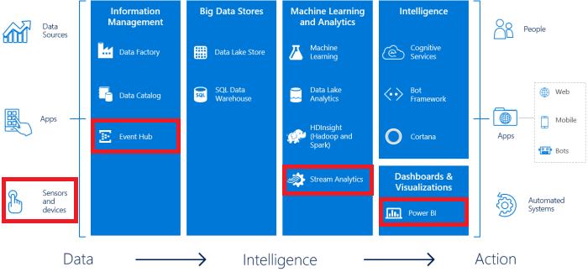
  2. **Scenario**:

This is a tutorial for analyzing stream data in real time and creating a live dashboard using Power BI. We will be using a bluetooth sensor (TI sensor) for sending data to Eventhub, Azure Stream Analytics will analyze it real time and send the output directly to Power BI.

* 1. **Learning Objectives:**

Upon completing this lab, you will have hands-on experience with the following functions and concepts related to Azure Event Hubs, Stream Analytics and Cortana Intelligence:

* Creating an Event Hub and Stream Analytics job using the Azure Management Portal
* Configuring input/query/output for a Stream Analytics job
* Sending data to an Event Hub and Visualizing real-time data in Power BI
  1. **Scenario Guide:** <https://gallery.cortanaintelligence.com/Tutorial/Sensor-Data-Analytics-with-ASA-and-Power-BI-2>

### Exercise 2: Sentiment analysis with Azure Stream Analytics and Machine Learning

This tutorial will show you how to set up a simple Azure Stream Analytics job, with Machine Learning integration. This tutorial uses a sentiment analytics Machine Learning model from the Cortana Intelligence Gallery to analyze streaming text data and determine the sentiment score in a real time.

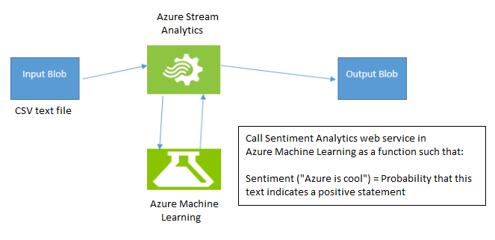

**Scenario**: This scenario use a sample CSV file with text in Azure Blob storage as input to Azure Stream Analytics, The job then applies the sentiment analytics model as a user-defined function on the sample text data and the end result is placed in the same blob store in other CSV file.

**Scenario Guide:** <https://azure.microsoft.com/en-us/documentation/articles/stream-analytics-machine-learning-integration-tutorial/>

### Exercise 3: Predictive Maintenance solution with Azure Machine Learning & HDInsight

This solution shows a predictive maintenance solution that leverage Event Hubs for ingesting aircraft sensor readings into Azure. Stream Analytics provides real-time insights on engine health and stores that data in long-term storage for more complex, compute-intensive batch analytics. HDInsight transforms the sensor data at scale which is then consumed by Machine Learning to predict the remaining useful life of aircraft engines and components after each flight. Data Factory handles orchestration, scheduling, and monitoring of the batch processing pipeline. Finally, Power BI allows technicians to monitor the real-time sensor data using visualizations to schedule maintenance on devices.

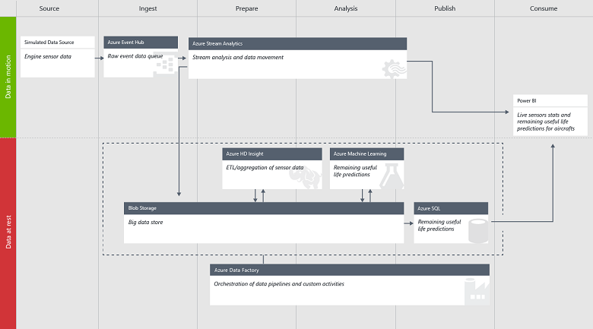

**Scenario**: The Cortana Intelligence Predictive Maintenance for Aerospace Solution Template monitors aircraft and predicts the remaining useful life of aircraft engine components.

**Scenario Guide:** <https://gallery.cortanaintelligence.com/SolutionTemplate/Predictive-Maintenance-for-Aerospace-1>

### Exercise 4: Intelligent Kiosk with Cognitive Services

* 1. The Intelligent Kiosk is a collection of demos showcasing workflows and experiences built on top of the Microsoft Cognitive Services. Most of the experiences are hands-free and autonomous, using the human faces in front of a web camera as the main form of input.
  2. **Scenario Guide:** <https://github.com/Microsoft/Cognitive-Samples-IntelligentKiosk/>

### Excercise 5: Customer churn analysis with Azure Machine Learning

This lab introduce to hosting machine learning models in Azure cloud. This lab create two different models based on the dataset called Churn. The dataset consists of records belonging to 4667 customers of a fictitious telecom service provider. The first model is churn analysis known as customer attrition which is the problem of identifying the customers who are likely to leave a service or a business. The goal of the analysis is to contact these high risk individuals and take necessary actions such as providing special offers and discounts to prevent them from leaving the business. The second model here is a segmentation model where th objective is to find natural clusters of customers within the data sets who have similar characteristics. This is also beneficial to understand the customer base for targeted marketing applications where the goal is to target the right individuals in order to grow the business. Follow the full documents in the following github repo to complete this lab.

**Scenario Guide:** <https://aka.ms/AzureMLChurnTutorial>

### Excercise 6: Rio Olympics 2016 Twitter sentiment Analytics using Azure SA&ML with PowerBI

This lab shows how to build a realtime twitter streaming sentiment analytics using Azure Event Hub, Azure Stream Analytics + Azure ML predictive solution function & finally building visualization using Microsoft PowerBI. The lab uses raw tweets events collection to pushing events into Event Hub, then publishing through ASA through AML predictive analytics sentiment values & finally implementing realtime sentiment scoring dashboard using PowerBI.

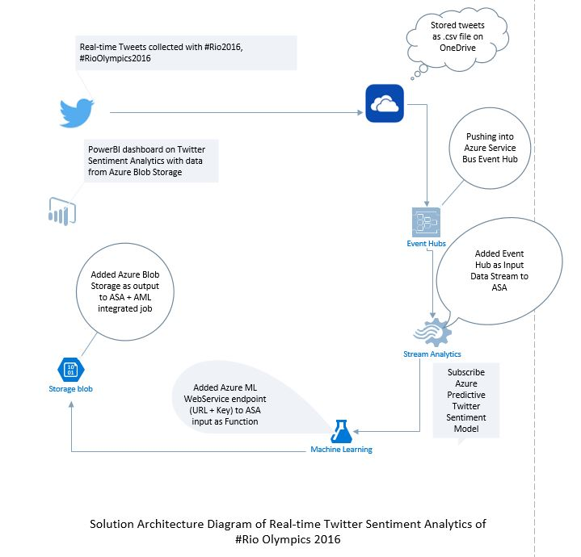

**Scenario Guide:** <https://blogs.msdn.microsoft.com/anindita9/2016/08/14/rioolympics2016-twitter-sentiment-analytics-using-azure-stream-analytics-azure-ml-with-predictive-analytics-using-powerbi/>